**LAB 12**

**CODE:**

**A) FIFO**

#include <stdio.h>

#include <conio.h>

int main() {

int i, j, k, f, pf = 0, count = 0, rs[25], m[10], n;

clrscr();

printf("\nEnter the length of reference string: ");

scanf("%d", &n);

printf("Enter the reference string: ");

for (i = 0; i < n; i++)

scanf("%d", &rs[i]);

printf("Enter number of frames: ");

scanf("%d", &f);

for (i = 0; i < f; i++) m[i] = -1;

printf("\nThe Page Replacement Process is:\n");

for (i = 0; i < n; i++) {

for (k = 0; k < f; k++) {

if (m[k] == rs[i]) break;

}

if (k == f) {

m[count++] = rs[i];

pf++;

}

for (j = 0; j < f; j++)

printf("\t%d", m[j]);

if (k == f)

printf("\tPF No. %d", pf);

printf("\n");

if (count == f) count = 0;

}

printf("\nTotal Page Faults using FIFO: %d\n", pf);

getch();

return 0;

}

**OUTPUT:**

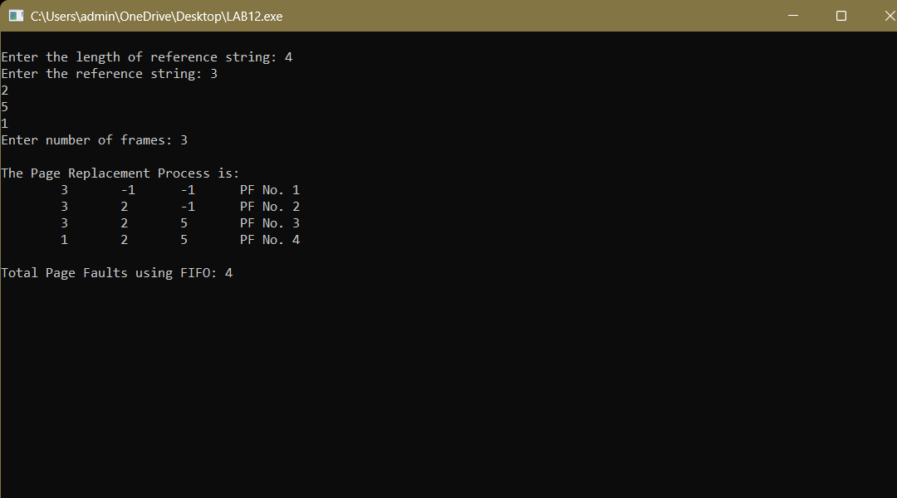

**B) LRU**

#include <stdio.h>

#include <conio.h>

int main() {

int i, j, k, min, rs[25], m[10], count[10], flag[25], n, f, pf = 0, next = 1;

clrscr();

printf("Enter the length of reference string: ");

scanf("%d", &n);

printf("Enter the reference string: ");

for (i = 0; i < n; i++) {

scanf("%d", &rs[i]);

flag[i] = 0;

}

printf("Enter number of frames: ");

scanf("%d", &f);

for (i = 0; i < f; i++) {

count[i] = 0;

m[i] = -1;

}

printf("\nThe Page Replacement Process is:\n");

for (i = 0; i < n; i++) {

for (j = 0; j < f; j++) {

if (m[j] == rs[i]) {

flag[i] = 1;

count[j] = next++;

}

}

if (flag[i] == 0) {

if (i < f) {

m[i] = rs[i];

count[i] = next++;

} else {

min = 0;

for (j = 1; j < f; j++)

if (count[min] > count[j])

min = j;

m[min] = rs[i];

count[min] = next++;

}

pf++;

}

for (j = 0; j < f; j++)

printf("%d\t", m[j]);

if (flag[i] == 0)

printf("PF No. -- %d", pf);

printf("\n");

}

printf("\nTotal Page Faults using LRU: %d\n", pf);

getch();

return 0;

}

**OUTPUT:**



**C) OPTIMAL Page Replacement**

#include <stdio.h>

int main() {

int no_of_frames, no_of_pages, frames[10], pages[30], temp[10];

int flag1, flag2, flag3, i, j, k, pos, max, faults = 0;

printf("Enter number of frames: ");

scanf("%d", &no_of_frames);

printf("Enter number of pages: ");

scanf("%d", &no_of_pages);

printf("Enter page reference string: ");

for (i = 0; i < no_of_pages; ++i)

scanf("%d", &pages[i]);

for (i = 0; i < no_of_frames; ++i)

frames[i] = -1;

for (i = 0; i < no_of_pages; ++i) {

flag1 = flag2 = 0;

for (j = 0; j < no_of_frames; ++j) {

if (frames[j] == pages[i]) {

flag1 = flag2 = 1;

break;

}

}

if (flag1 == 0) {

for (j = 0; j < no_of_frames; ++j) {

if (frames[j] == -1) {

frames[j] = pages[i];

faults++;

flag2 = 1;

break;

}

}

}

if (flag2 == 0) {

flag3 = 0;

for (j = 0; j < no_of_frames; ++j) {

temp[j] = -1;

for (k = i + 1; k < no_of_pages; ++k) {

if (frames[j] == pages[k]) {

temp[j] = k;

break;

}

}

}

for (j = 0; j < no_of_frames; ++j) {

if (temp[j] == -1) {

pos = j;

flag3 = 1;

break;

}

}

if (flag3 == 0) {

max = temp[0];

pos = 0;

for (j = 1; j < no_of_frames; ++j) {

if (temp[j] > max) {

max = temp[j];

pos = j;

}

}

}

frames[pos] = pages[i];

faults++;

}

for (j = 0; j < no_of_frames; ++j)

printf("%d\t", frames[j]);

printf("\n");

}

printf("\nTotal Page Faults using OPTIMAL: %d\n", faults);

return 0;

}

**OUTPUT:**



**D) MRU**

#include <iostream>

using namespace std;

// Update array in MRU fashion

void recently(int* arr, int size, int elem) {

int index = elem % size;

int temp = index, id = arr[index];

while (temp > 0)

arr[temp] = arr[--temp];

arr[0] = id;

}

// Print array

void print(int* arr, int size) {

for (int i = 0; i < size; i++)

cout << arr[i] << " ";

cout << endl;

}

int main() {

int elem = 3;

int arr[] = {6, 1, 9, 5, 3};

int size = sizeof(arr) / sizeof(arr[0]);

recently(arr, size, elem);

cout << "Array in Most Recently Used fashion: ";

print(arr, size);

return 0;

}

**OUTPUT:**

